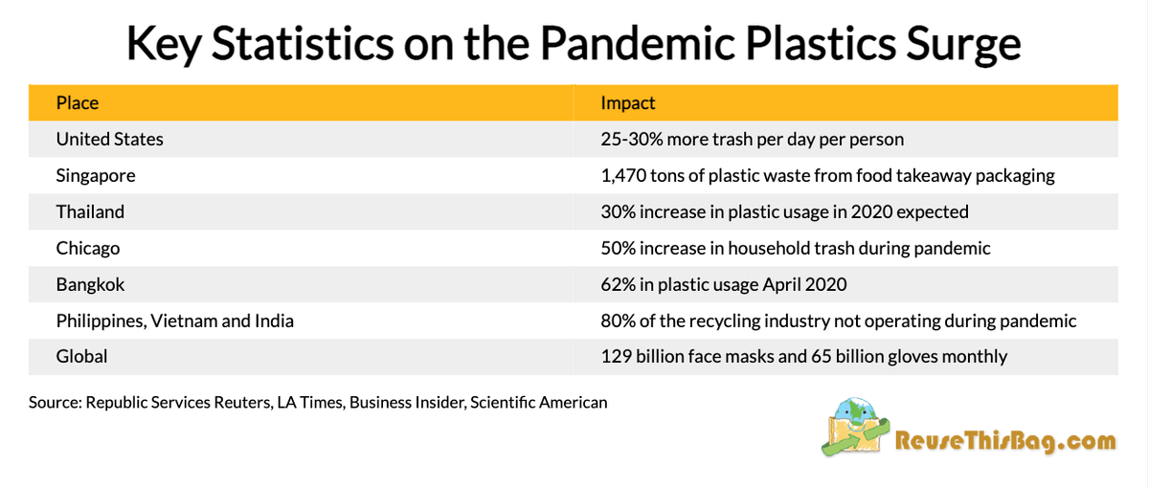

Unique/good

Different variable were tested

They have city and county impacts as well as global impact

Issue

While I like that they have several different locations I do think that more similar comparable locations would have been more ideal.

<https://learn.jewell.edu/d2l/le/content/7050/viewContent/15522/View>

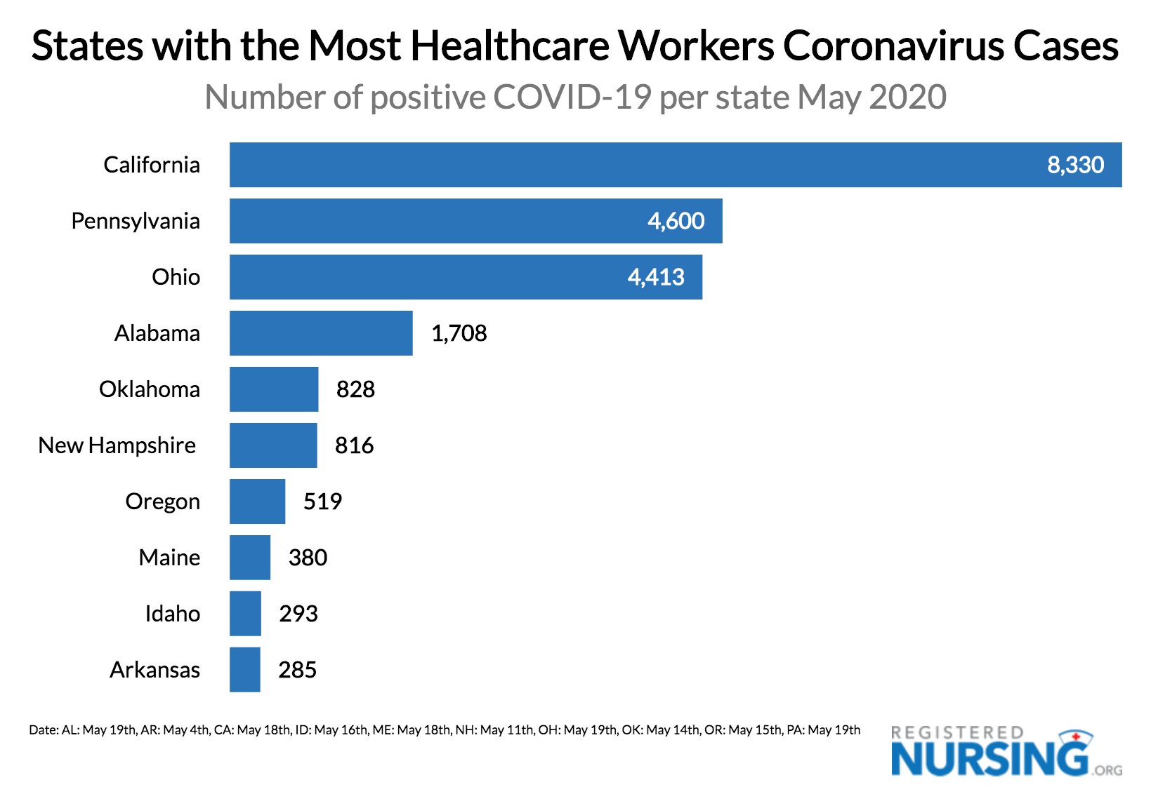

Unique/good

I like that it compares state to state of the top ten highest states.

I like that it is showing the healthcare workers infections.

Issues

I do not like that this graphic is for only the time period of may 2020 over time would have been more helpful one month will not show the full effect of the virus but rather the effect of the virus at a specific moment.

<https://learn.jewell.edu/d2l/le/content/7050/viewContent/15522/View>

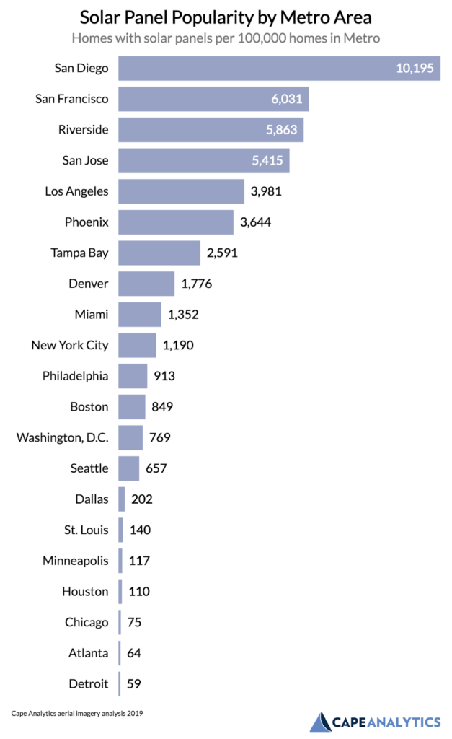

Good/unique

Shows a good amount of info based of city areas

Easy to read and easy to understand

Issues

I think a state to state comparison would also be appropriate for this comparison.

<https://learn.jewell.edu/d2l/le/content/7050/viewContent/15522/View>

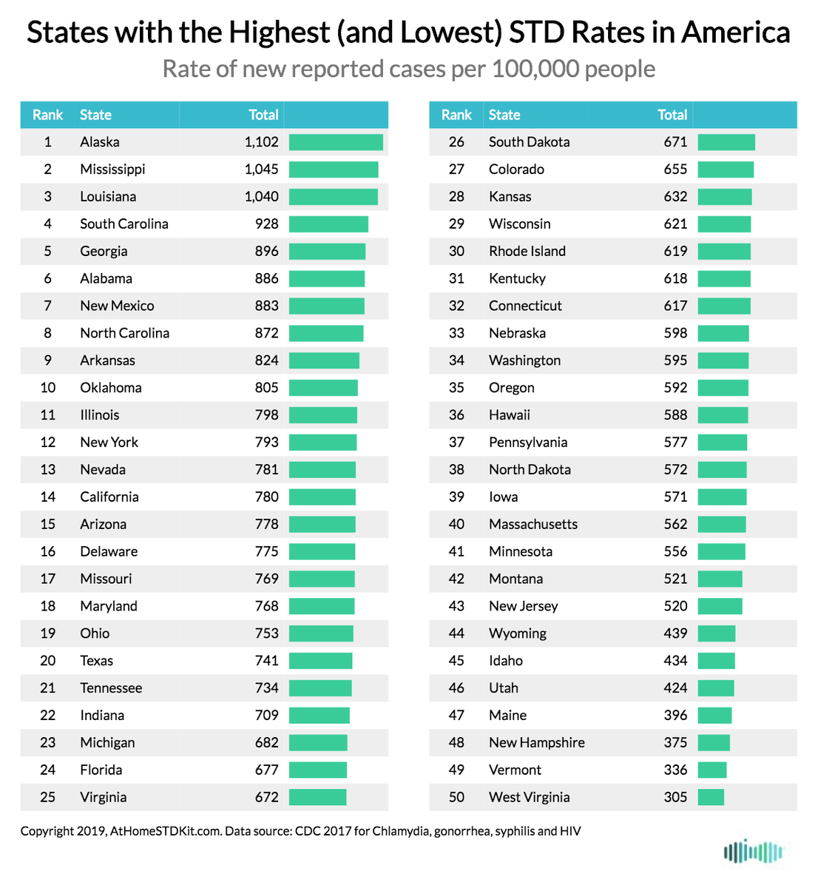

Good/unique

A lot of comparison

Shows all 50 states

Issues

It is a lot to take in with not much proven from the graphic.

<https://learn.jewell.edu/d2l/le/content/7050/viewContent/15522/View>